**Final Project Report**

on

**Online Library Management System**

At

**COMPUCOM INSTITUTE OF INFORMATION TECHNOLOGY AND MANAGEMENT**

**Computer Science Engineering**



**COMPUCOM INSTITUTE OF INFORMATION TECHNOLOGY AND MANAGEMENT**

SP-5, EPIP, Sitapura, RIICO industrial area, Jaipur-30200

Email: adm@ciitm.org

Website: www.ciitm.org

**SUBMITTED TO: SUBMITTED BY:**

**Mr. Manish Suroliya Pravesh Kumar Sharma**

Acknowledgement

I am highly grateful to the **Mr. Manish Suroliya**, HOD(CS), **Compucom Institute of Information Technology and Management**, for providing this opportunity to carry out the Major Project at **Online Library Management System.**

The help rendered by **Mr. Manish Suroliya**, for experimentation is greatly acknowledged.

Finally, I express my indebtedness to all who have directly or indirectly contributed to the successful completion of my major project.

I would like to expresses my gratitude to other faculty members of our college, for providing academic inputs, guidance & encouragement throughout this period.

I would like to express a deep sense of gratitude and thank **Mr. Manish Suroliya**, without whose permission, wise counsel and able guidance, it would have not been possible to carry out my project in this manner.

Preface

In today's competitive world, computers have assumed critical importance in every field. It has become an essential qualification for almost all ventures. In my Digree of Computer Science, I have been prepared to be at par with the industrial requirements. But theoretical knowledge is not just enough in present areas. Theoretical knowledge accompanied with the practical knows how of the industrial environment makes me ready for making a good performance when I enter the industry.

Pravesh Kumar Sharma

Index

|  |  |  |
| --- | --- | --- |
| **Chapter No.** | **Content** | **Page No.** |
|  | **Abstract** | 5 |
| **Chapter - 1** | **Introduction** | 6 - 8 |
| 1.1 | Project aims and Objectives | 6 |
| 1.2 | Background of project | 7 |
| 1.3 | Operation environment | 8 |
| **Chapter - 2** | **System Analysis** | 9 - 17 |
| 2.1 | Software Requirement Specification (SRS) | 9 |
| 2.2 | Existing v/s Proposed | 14 |
| 2.3 | Software tool used | 15 |
| **Chapter - 3** | **Overview of PHP** | 18 - 23 |
| 3.1 | Environment Setup | 18 |
| 3.2 | Syntax | 19 |
| 3.3 | Variable | 19 |
| 3.4 | Decision Making Statement | 20 |
| 3.5 | Loops | 21 |
| 3.6 | GET and POST | 22 |
| 3.7 | Functions | 23 |
| **Chapter - 4** | **System Design** | 24 - 33 |
| 4.1 | Table Design | 24 |
| 4.2 | Data Flow Diagram (DFD) | 28 |
| **Chapter - 5** | **System Implementation** | 34 - 39 |
| 5.1 | Screenshots | 34 |
| **Chapter - 6** | **System Testing** | 40 - 42 |
| 6.1 | Unit Testing | 40 |
| 6.2 | Integration Testing | 42 |
| **Chapter - 7** | **Conclusion and Future Scope** | 43 |
| **Chapter - 8** | **References** | 44 |

**Abstract**

Library management system is a project which aims in developing a computerized system to maintain all the daily work of library .This project has many features which are generally not availiable in normal library management systems like facility of user login and a facility of admin login .It also has a facility of admin login through which the admin can monitor the whole system . It has also a facility where student after logging in their accounts can see list of books issued and its issue date and return date.

Overall this project of ours is being developed to help the students as well as staff of library to maintain the library in the best way possible and also reduce the human efforts.

**Chapter 1**

**Introduction**

This chapter gives an overview about the aim , objectives ,background and

operation environment of the system.

**1.1 Project aims and objectives:**

The project aims and objectives that will be achieved after completion of this project are discussed in this subchapter. The aims and objectives are as follows:

* Online book issue
* Request column for librarian for providing new books
* Student login page where student can find books issued by him/her and date of return.
* A search column to search availability of books

**1.2 Background of project:**

Library Management System is an application which refers to library systems which are generally small or medium in size. It is used by librarian to manage the library using a computerized system where he/she can record various transactions like issue of books, return of books, addition of new books, addition of new students etc.

Books and student maintenance modules are also included in this system which would keep track of the students using the library and also a detailed description about the books a library contains. With this computerized system there will be no loss of book record or member record which generally happens when a non computerized system is used.

All these modules are able to help librarian to manage the library with more convenience and in a more efficient way as compared to library systems which are not computerized.

**1.3 Operation environment:**

|  |  |
| --- | --- |
| **Processor** | Intel core processor or better performance |
| **Operating System** | Windows/Linux/Mac |
| **Memory** | 1 GB ram or more |
| **Hard disk** | Minimum 3 GB for database usage for future |
| **Database** | MySQL |

**Chapter 2**

**System Analysis**

In this chapter, we will discuss and analyze about the developing process of Library Management System including software requirement specification (SRS) and comparison between existing and proposed system . The functional and non functional requirements are included in SRS part to provide complete description and overview of system requirement before the developing process is carried out. Besides that, existing vs proposed provides a view of how the proposed system will be more efficient than the existing one.

**2.1 Software Requirement Specification(SRS):**

**2.1.1 General Description:**

**Product Description:**

Library Management System is a computerized system which helps user (librarian) to manage the library daily activity in electronic format. It reduces the risk of paper work such as file lost, file damaged and time consuming.

It can help user to manage the transaction or record more effectively and time-

saving.

**Problem Statement:**

The problem occurred before having computerized system includes:

* **File lost:**

When computerized system is not implemented file is always lost because of human environment.Some times due to some human error there may be a loss of records.

* **File damaged:**

When a computerized system is not there file is always lost due to some accdent like spilling of water by some member on file accidentally.Besides some natural disaster like floods or fires may also damage the files.

* **Difficult to search record:**

When there is no computerized system there is always a difficulty in searching of

records if the records are large in number .

* **Space consuming:**

After the number of records become large the space for physical storage of file and records also increases if no computerized system is implemented.

* **Cost consuming:**

As there is no computerized system the to add each record paper will be needed

which will increase the cost for the management of library.

**2.1.2 System Objectives:**

* **Improvement in control and performance:**

The system is developed to cope up with the current issues and problems of library. The system can add user, validate user and is also bug free.

* **Save cost:**

After computerized system is implemented less human force will be required

to maintain the library thus reducing the overall cost.

* **Save time:**

Librarian is able to search record by using few clicks of mouse and few search

keywords thus saving his valuable time.

* **Option of online Notice board:**

Librarian will be able to provide a detailed description of workshops going in the

college as well as in nearby colleges

* **Lecture Notes:**

Teacher have a facility to upload lectures notes in a pdf file having size not more

than 10mb

**2.1.3 System Requirements:**

**2.1.3.1 Non Functional Requirements:**

1. **Product Requirements:**

* **Efficiency Requirement:**

When a library management system will be implemented librarian and user will

easily acess library as searching and book transaction will be very faster.

* **Reliability Requirement:**

The system should accurately performs member registration ,member validation ,

report generation, book transaction and search.

* **Usability Requirement:**

The system is designed for a user friendly environment so that student and staff of library can perform the various tasks easily and in an effective way.

1. **Organizational Requirement:**

* **Implementation Requiremnts:**

In implementing whole system it uses html in front end with php as server side

scripting language which will be used for database connectivity and the backend ie the database part is developed using mysql.

* **Delivery Requirements:**

The whole system is expected to be delivered in six months of time with a weekly

evaluation by the project guide.

**2.1.3.2 Functional Requirements:**

1. **Normal User:**
   1. **User Login:**

* **Description of feature:**

This feature used by the user to login into system. They are required to enter user id and password before they are allowed to enter the system .The user id and password will be verified and if invalid id is there user is allowed to not enter the system.

* **Functional requirements:**
* user id is provided when they register
* The system must only allow user with valid id and password to enter the system
* The system performs authorization process which decides what user level can acess to.
* The user must be able to logout after they finished using system.
  1. **Register New User:**
* **Description of feature:**

This feature can be performed by all users to register new user to create account.

* **Functional requirements:**
* System must be able to verify information
* System must be able to delete information if information is wrong
* **Admin Features:**
* Admin Dashboard
* Admin can add/update/ delete category
* Admin can add/update/ delete author
* Admin can add/update/ delete books
* Admin can issue a new book to student and also update the details when student return book
* Admin can search student by using their student ID
* Admin can also view student details
* Admin can change own password
* **Students Features:**
* Student can register yourself and after registration they will get studentid
* After login student can view own dashboard.
* Student can update own profile.
* Student can view issued book and book return date-time.
* Student can also change own password.
* Student can also recover own password.

**2.1.4 Software And Hardware Requirements:**

This section describes the software and hardware requirements of the system.

**2.1.5.1 Software Requirements:**

* **Operating system:**

Windows 7 is used as the operating system as it is stable and supports more features and is more user friendly

* **Database:**

**MYSQL** is used as database as it easy to maintain and retrieve records by simple queries which are in English language which are easy to understand and easy to write.

* **Development tools and Programming language:**

**HTML** is used to write the whole code and develop webpages with css, java script for styling work and **PHP** for sever side scripting.

**2.1.5.2 Hardware Requirements:**

* Intel core i5 2 generation is used as a processor because it is fast than other processors an provide reliable and stable and we can run our pc for longtime. By using this processor we can keep on developing our project without any worries.
* Ram 1 gb is used as it will provide fast reading and writing capabilities and will in turn support in processing

**2.2 Existing Vs Proposed System:**

* Existing system does not have any facility of teachers login or student login where as proposed system will have a facility of student login as well as teacher’s login.
* Existing system does not have a facility of online reservation of books whereas proposed system has a facility of online reservation of books.
* Existing system does not have any facility of online notice board where description of workshops happening in our college as well as nearby colleges is being provided.
* Existing system does not has any option of lectures notes uploaded by teachers whereas proposed system will have this facility.
* Existing system does not have any facility to generate student reports as well book issue reports whereas proposed system provides librarian with a tool to generate reports.
* Existing system does not has any facility for book request and sugeestions where as in proposed system after logging in to their accounts student can request books as well as provide suggestions to improve library.

**2.3 Software Tools Used:**

The whole Project is divided in two parts the front end and the back end.

**2.3.1 Front end:**

The front end is designed using of html , Php ,css, Javascript.

1. **HTML:**

HTML or Hyper Text Markup Language is the main markup language for creating web pages and other information that can be displayed in a web browser.HTML is written in the form of HTML elements consisting of tags enclosed in angle brackets (like <html>), within the web page content. HTML tags most commonly come in pairs like <h1> and </h1>, although some tags represent empty elements and so are unpaired, for example <img>. The first tag in a pair is the start tag, and the second tag is the end tag (they are also called opening tags and closing tags). In between these tags web designers can add text, further tags, comments and other types of text-based content. The purpose of a web browser is to read HTML documents and compose them into visible or audible web pages. The browser does not display the HTML tags, but uses the tags to interpret the content of the page.HTML elements form the building blocks of all websites. HTML allows images and objects to be embedded and can be used to create interactive forms. It provides a means to create structured documents by denoting structural semantics for text such as headings, paragraphs, lists, links, quotes and other items. It can embed scripts written in languages such as JavaScript which affect the behavior of HTML web pages.

1. **CSS:**

Cascading Style Sheets (CSS) is a style sheet language used for describing the look and formatting of a document written in a markup language. While most often used to style web pages and interfaces written in HTML and XHTML, the language can be applied to any kind of XML document, including plain XML, SVG and XUL. CSS is a cornerstone specification of the web and almost all web pages use CSS style sheets to describe their presentation.CSS is designed primarily to enable the separation of document content from document presentation, including elements such as the layout, colors, and fonts. This separation can improve content accessibility, provide more flexibility and control in the specification of presentation characteristics, enable multiple pages to share formatting, and reduce complexity and repetition in the structural content (such as by allowing for table less web design).CSS can also allow the same markup page to be presented in different styles for different rendering methods, such as on-screen, in print, by voice (when read out by a speech-based browser or screen reader) and on Braille-based, tactile devices. It can also be used to allow the web page to display differently depending on the screen size or device on which it is being viewed. While the author of a document typically links that document to a CSS file, readers can use a different style sheet, perhaps one on their own computer, to override the one the author has specified. However if the author or the reader did not link the document to a specific style sheet the default style of the browser will be applied.CSS specifies a priority scheme to determine which style rules apply if more than one rule matches against a particular element. In this so-called cascade, priorities or weights are calculated and assigned to rules, so that the results are predictable.

**JAVASCRIPT:**

JavaScript (JS) is a dynamic computer programming language. It is most commonly used as part of web browsers, whose implementations allow client-side scripts to interact with the user, control the browser, communicate asynchronously, and alter the document content that is displayed. It is also being used in server-side programming, game development and the creation of desktop and mobile applications. JavaScript is a prototype-based scripting language with dynamic typing and has first-class functions. Its syntax was influenced by C. JavaScript copies many names and naming conventions from Java, but the two languages are otherwise unrelated and have very different semantics. The key design principles within JavaScript are taken from the Self and Scheme programming languages. It is a multi-paradigm language, supporting object-oriented, imperative, and functional programming styles. The application of JavaScript to use outside of web pages—for example, in PDF documents, site-specific browsers, and desktop widgets—is also significant. Newer and faster JavaScript VMs and platforms built upon them (notably Node.js) have also increased the popularity of JavaScript for server-side web applications. On the client side, JavaScript was traditionally implemented as an interpreted language but just-in-time compilation is now performed by recent (post-2012) browsers.

**PHP:**

PHP is a server-side scripting language designed for web development but also used as a general-purpose programming language. PHP is now installed on more than 244 million websites and 2.1 million web servers. Originally created by Rasmus Lerdorf in 1995, the reference implementation of PHP is now produced by The PHP Group. While PHP originally stood for Personal Home Page, it now stands for PHP: Hypertext Preprocessor, a recursive backronym.PHP code is interpreted by a web server with a PHP processor module, which generates the resulting web page: PHP commands can be embedded directly into an HTML source document rather than calling an external file to process data. It has also evolved to include a command-line interface capability and can be used in standalone graphical applications. PHP is free software released under the PHP License. PHP can be deployed on most web servers and also as a standalone shell on almost every operating system and platform, free of charge.

**2.3.2 Back End:**

The back end is designed using mysql which is databases.

➢

**MySQL:**

MySQL ("My S-Q-L", officially, but also called "My Sequel") is (as of July 2013) the world's second most widely used open-source relational database management system (RDBMS). It is named after co-founder Michael Widenius

daughter, My. The SQL phrase stands for Structured Query Language. The MySQL development project has made its source code available under the terms of the GNU General Public License, as well as under a variety of proprietary agreements. MySQL was owned and sponsored by a single for-profit firm, the Swedish company MySQL AB, now owned by Oracle Corporation. MySQL is a popular choice of database for use in web applications, and is a central component of the widely used LAMP open source web application software stack (and other 'AMP' stacks). LAMP is an acronym for "Linux, Apache, MySQL, Perl/PHP/Python." Free-software-open source projects that require a full-featured database management system often use MySQL. For commercial use, several paid editions are available, and offer additional functionality. Applications which use MySQL databases include: TYPO3, MODx, Joomla, WordPress, phpBB, MyBB, Drupal and other software. MySQL is also used in many high-profile, large-scale websites, including Wikipedia, Google (though not for searches), Facebook, Twitter, Flickr, and YouTube

Chapter - 3

Overview Of PHP

* **PHP is a recursive acronym for "PHP: Hypertext Preprocessor".**

PHP is a server-side scripting language that enables us to build dynamic web pages. PHP pages may contain text, HTML, and script blocks. When a browser requests a PHP page, the PHP script is executed on the web server, and the resulting HTML is displayed in the browser.

* It is used to manage dynamic content, databases, session tracking, even build entire e-commerce sites.
* It is integrated with a number of popular databases, including MySQL, PostgreSQL, Oracle, Sybase, Informix, and Microsoft SQL Server.

A PHP page must have a PHP-supported extension. Typically, a PHP file ends with .php, although other PHP extensions such as .php4 and .phtml also exist. However, .php is the most common extension.

***3.1 Environment Setup:-***

In order to develop and run PHP Web pages three components need to be installed on your computer system.

* **Web Server:** PHP will work with virtually all Web Server software, including Microsoft's Internet Information Server (IIS) but then most often used is freely available Apache Server.
* **Database:** PHP will work with virtually all database software, including Oracle and Sybase but most commonly used is freely available MySQL database.
* **PHP Parser:** In order to process PHP script instructions a parser must be installed to generate HTML output that can be sent to the Web Browser. This tutorial will guide you how to install PHP parser on your computer.

**3.2 Syntex:** The most universally effective PHP tag style is −

**<?php**

// PHP code goes here

**?>**

**3.3 Variables:**

The main way to store information in the middle of a PHP program is by using a variable.

* All variables in PHP are denoted with a leading dollar sign ($).
* Variables are assigned with the = operator, with the variable on the left-hand side and the expression to be evaluated on the right.
* PHP does a good job of automatically converting types from one to another when necessary.
* PHP has a total eight data types as integer, double, NULL, boolean, string, array, object, resources.

**Ex: $x** , **$x=50** , **$name=”rajesh”**etc.

**3.4 Decision Making Statements:**

PHP supports following three decision making statements −

* **if...else statement:**

It is use this statement if you want to execute a set of code when a condition is true and another if the condition is not true

* **elseif statement:**

It is used with the if...else statement to execute a set of code if **one** of the several condition is true

* **switch statement:**

It is used if you want to select one of many blocks of code to be executed, use the Switch statement. The switch statement is used to avoid long blocks of if..elseif..else code.

### **Syntax:-**

**if (condition)**

**code to be executed if condition is true;**

**else**

**code to be executed if condition is false;**

**3.5 Loops:**

Loops in PHP are used to execute the same block of code a specified number of times.

* **for:**

It loops through a block of code a specified number of times.

**Syntex:**

**for (initialization; condition; increment){**

**code to be executed;**

**}**

* **while:**

It loops through a block of code if and as long as a specified condition is true.

**Syntex:**

**while (*condition*) {**

***code to be executed;***

**}**

* **do...while:**

It loops through a block of code once, and then repeats the loop as long as a special condition is true.

**Syntex:**

**do {**

***code to be executed;***

**}**

**while (*condition*);**

***3.6 GET & POST:***

## GET Method: The GET method sends the encoded user information appended to the page request. The page and the encoded information are separated by the ? character.

* The GET method produces a long string that appears in your server logs, in the browser's Location: box.
* The GET method is restricted to send upto 1024 characters only.
* Never use GET method if you have password or other sensitive information to be sent to the server.
* GET can't be used to send binary data, like images or word documents, to the server.
* The data sent by GET method can be accessed using QUERY_STRING environment variable.
* The PHP provides **$_GET** associative array to access all the sent information using GET method.

## POST Method: The POST method transfers information via HTTP headers. The information is encoded as described in case of GET method and put into a header called QUERY_STRING.

* The POST method does not have any restriction on data size to be sent.
* The POST method can be used to send ASCII as well as binary data.
* The data sent by POST method goes through HTTP header so security depends on HTTP protocol. By using Secure HTTP you can make sure that your information is secure.
* The PHP provides **$_POST** associative array to access all the sent information using POST method.

**3.7 Functions:**

A function is a piece of code which takes one more input in the form of parameter and does some processing and returns a value.

## Creating PHP Function:

<?php

/* Defining a PHP Function */

**function** writeMessage() {

echo "You are really a nice person, Have a nice time!";

}

/* Calling a PHP Function */

writeMessage();

?>

**Chapter 4**

**System Design**

**4.1 Table Design:**

Various Tabels To Maintain Information:



1. **Admin table:**

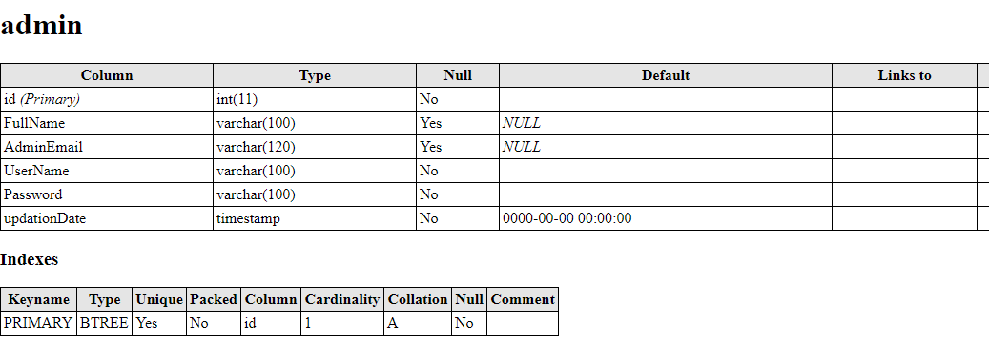

**Table tblauthors track the details of authors:**

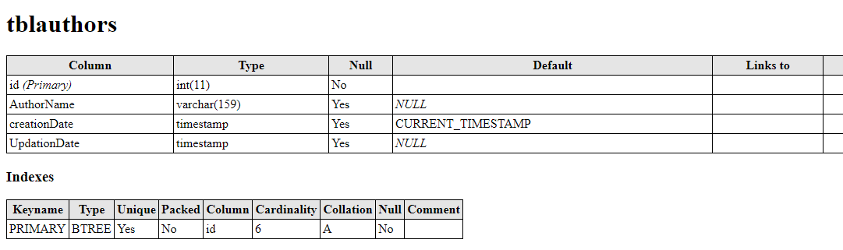

**Table tblcategory track the record of category:**

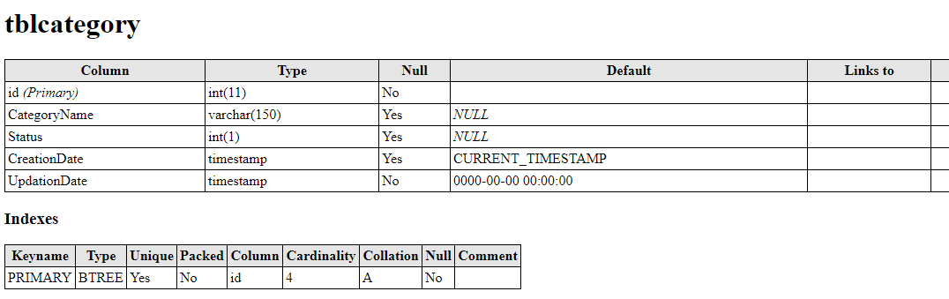

**Table tbalbooks for books records:**

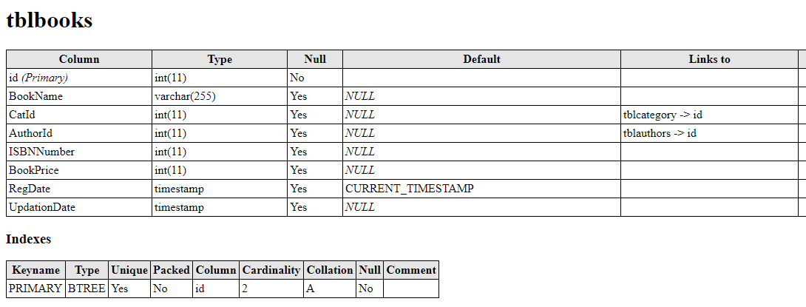

**Table tblstudents for students record and student login details:**

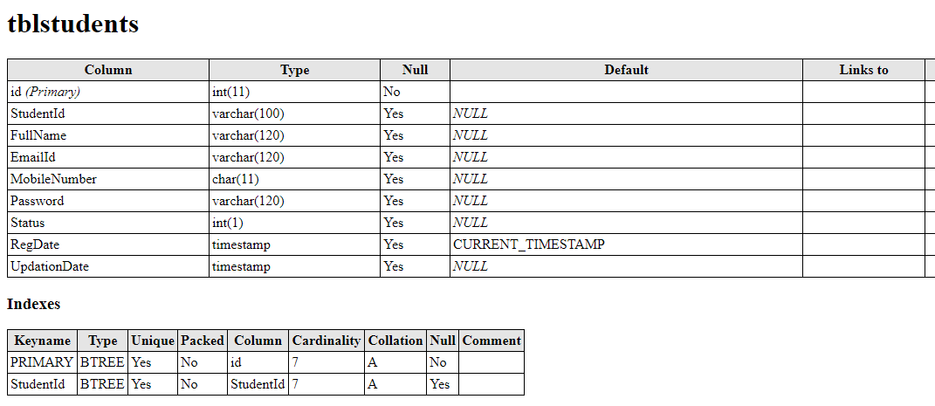

Table tblissuedbookdetails for maintain issued book and returned book record

**Relationship between tables:**

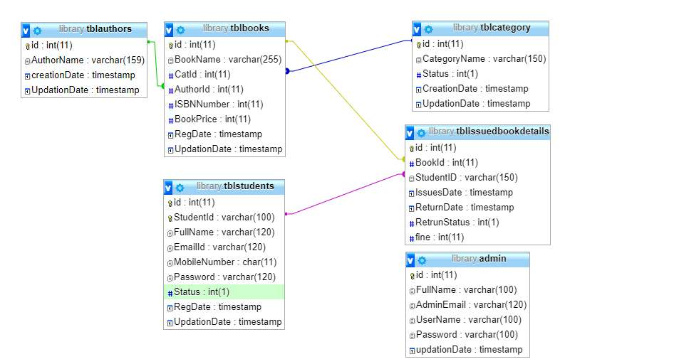

**4.2 Data Flow Diagrams:**

1. **Data Flow Diagram For Admin Login:**

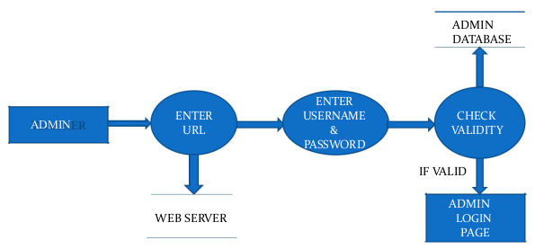

After entering to the home page of the website , Admin can choose the ADMIN LOGIN option where they are asked to enter username & password , and if he/she is a valid user then a teacher login page will be displayed.

1. **Admin Dataflow diagram:**

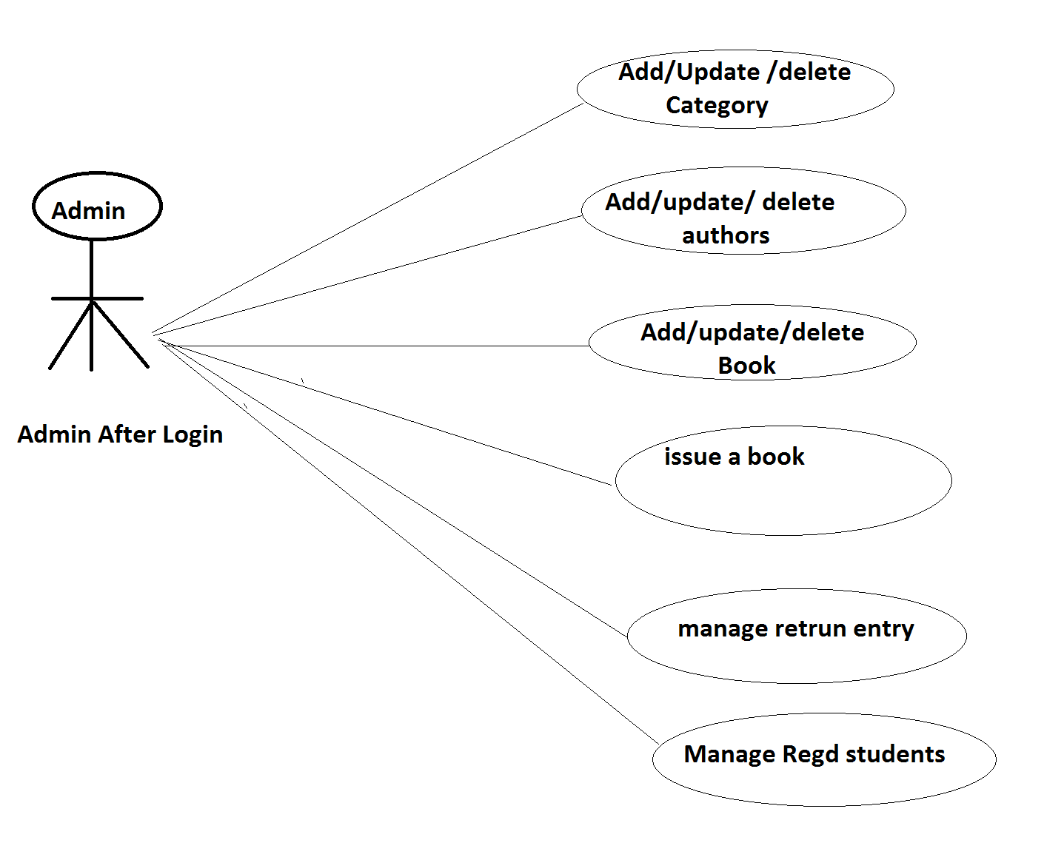

1. **Data Flow Diagram For Issuing Book:**

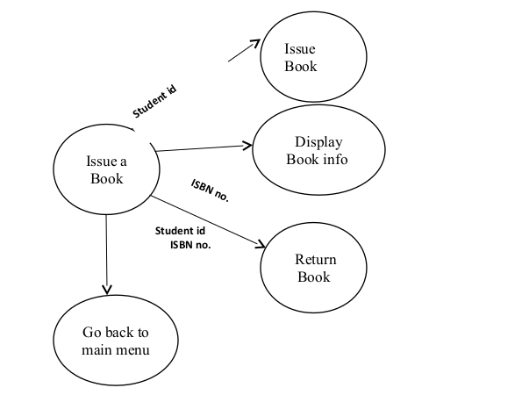

1. **Data Flow Diagram for Students:**

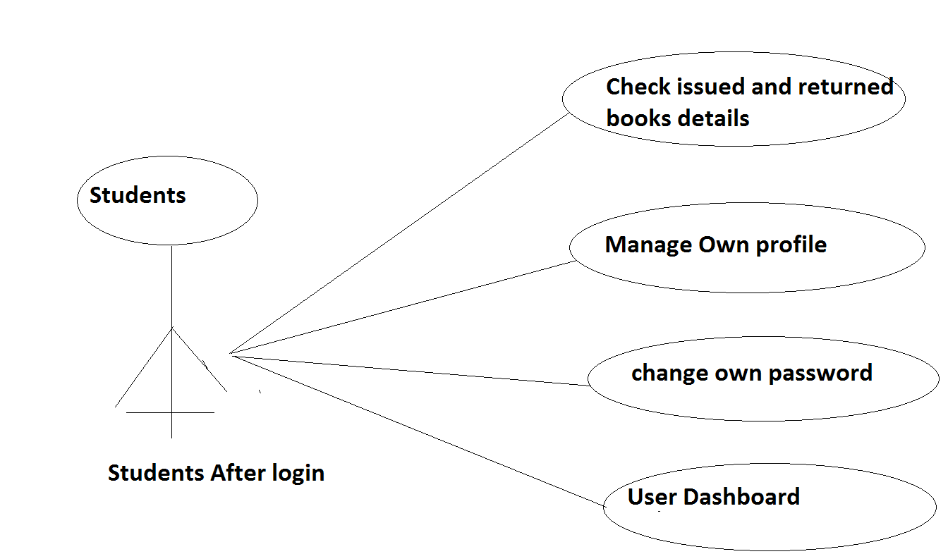

**4.3 Entity Relationship Diagram:**

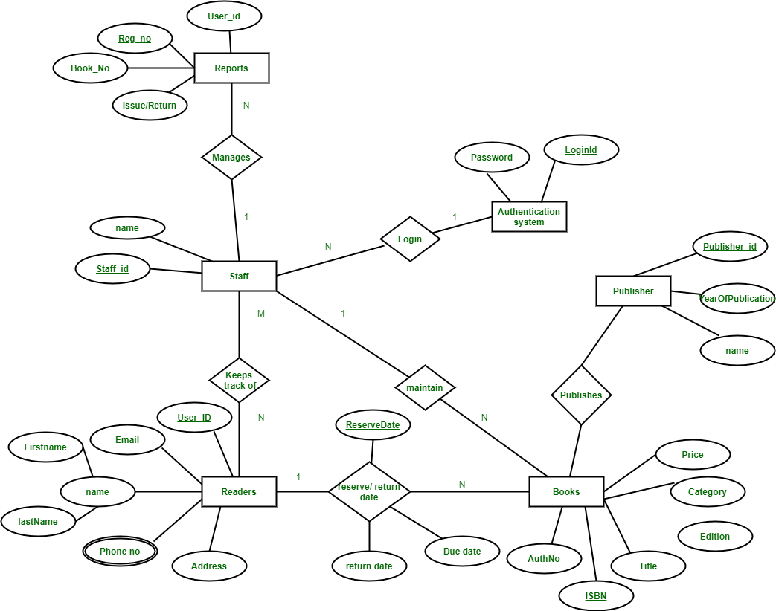

**4.4 Testing:**

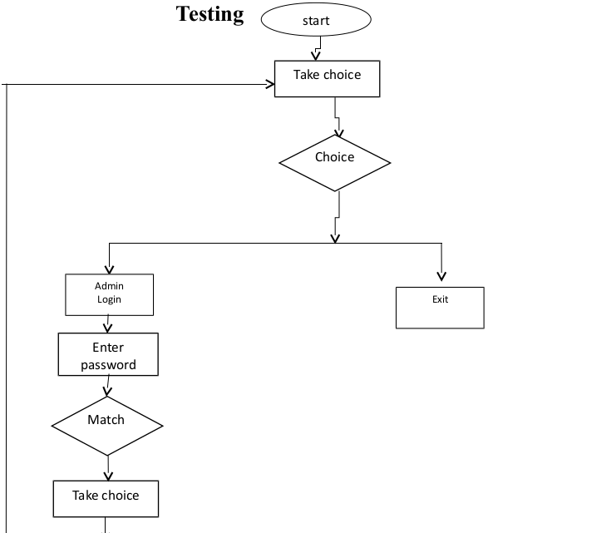

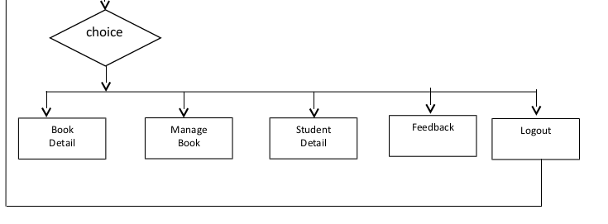

**Chapter 5**

**System Implementation**

**5.1 Screenshot:**

**Home:**

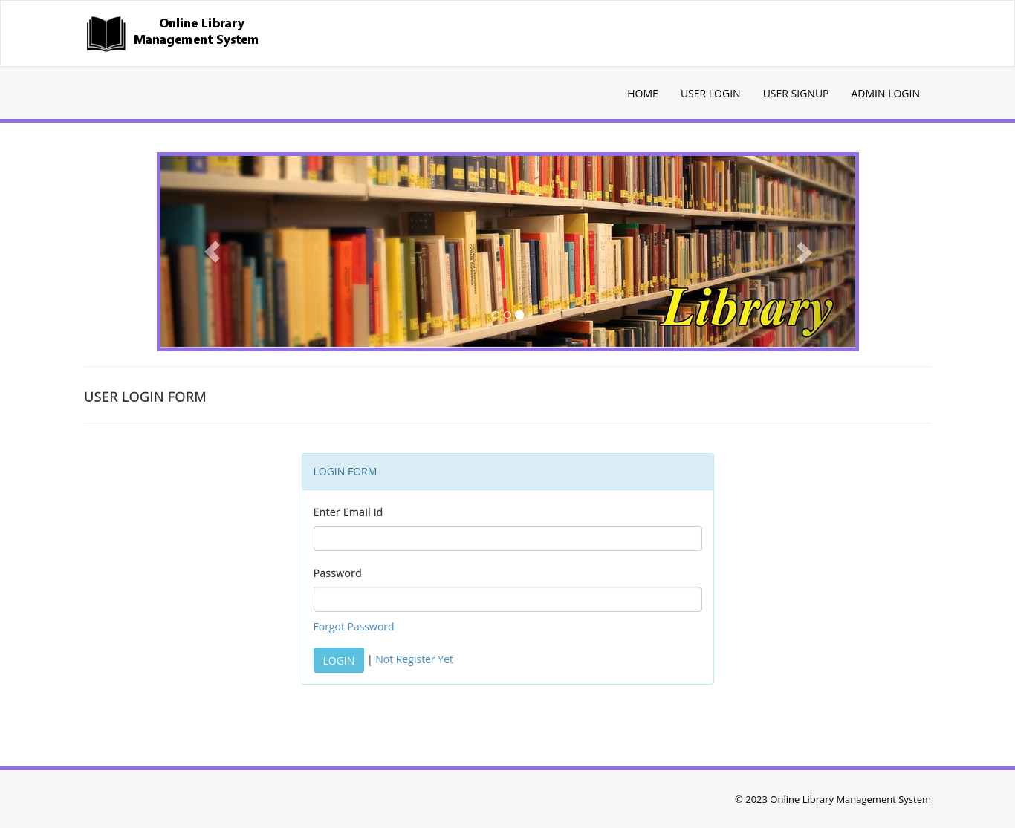

**User signup:**

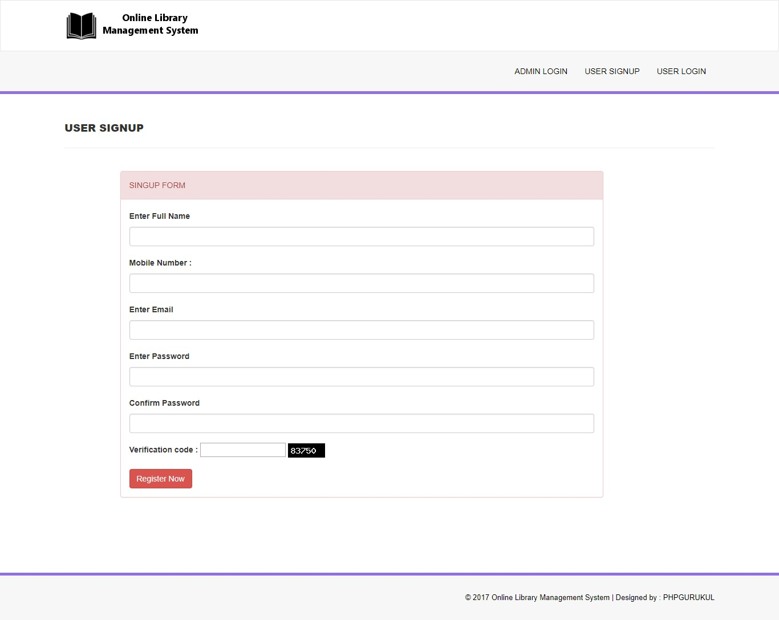

**User Dashboard:**

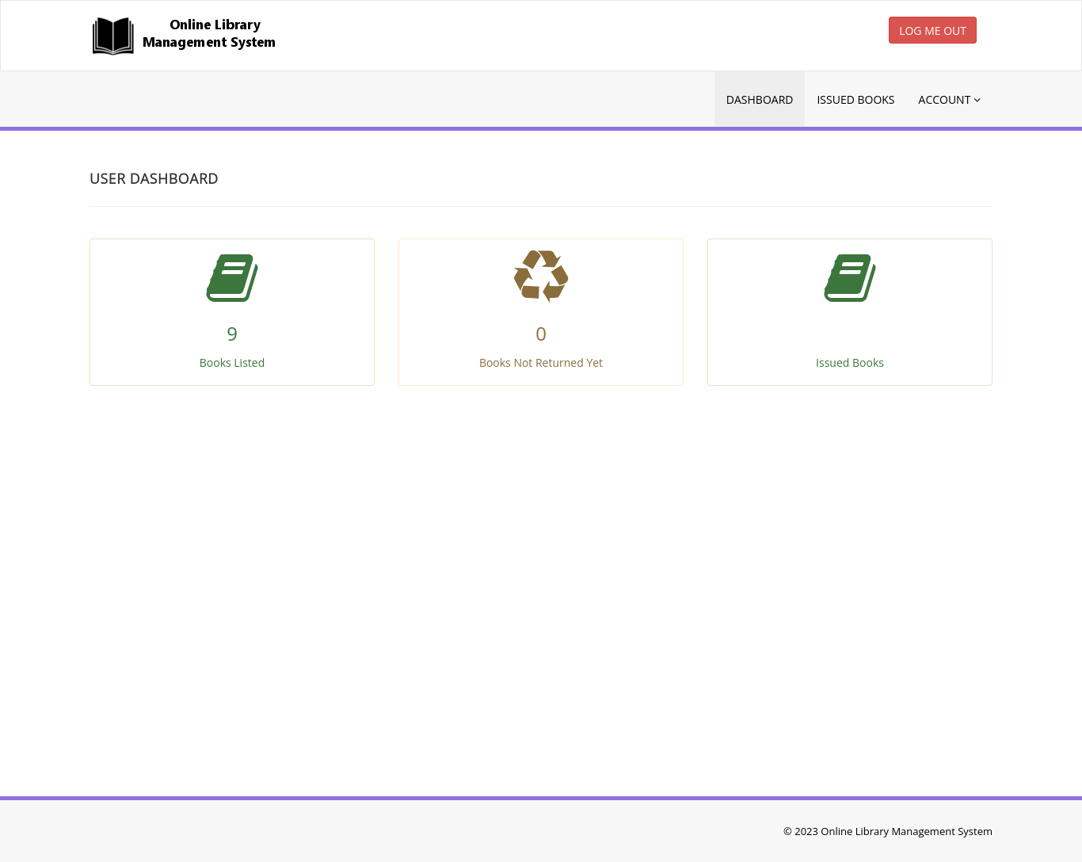

**Books Listed:**

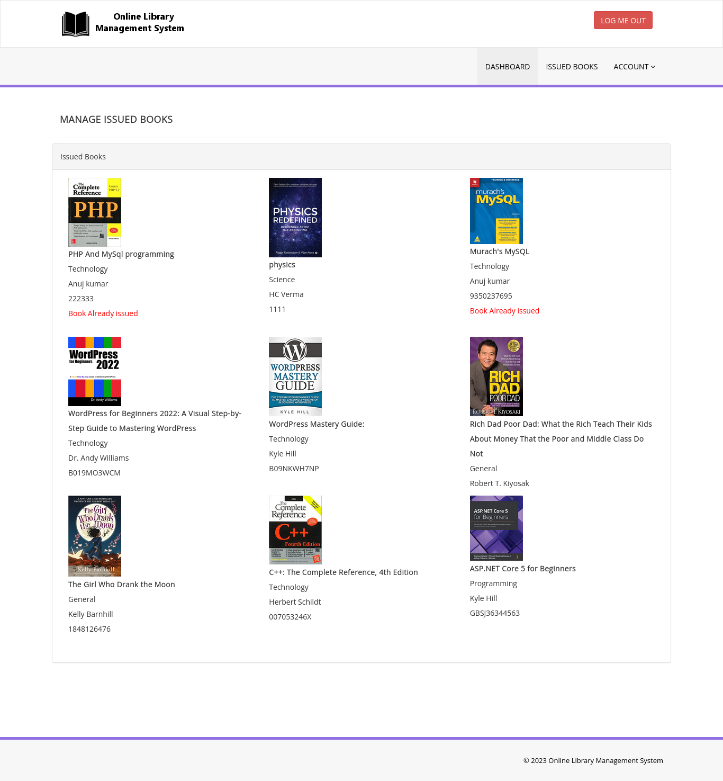

**Issued Books:**

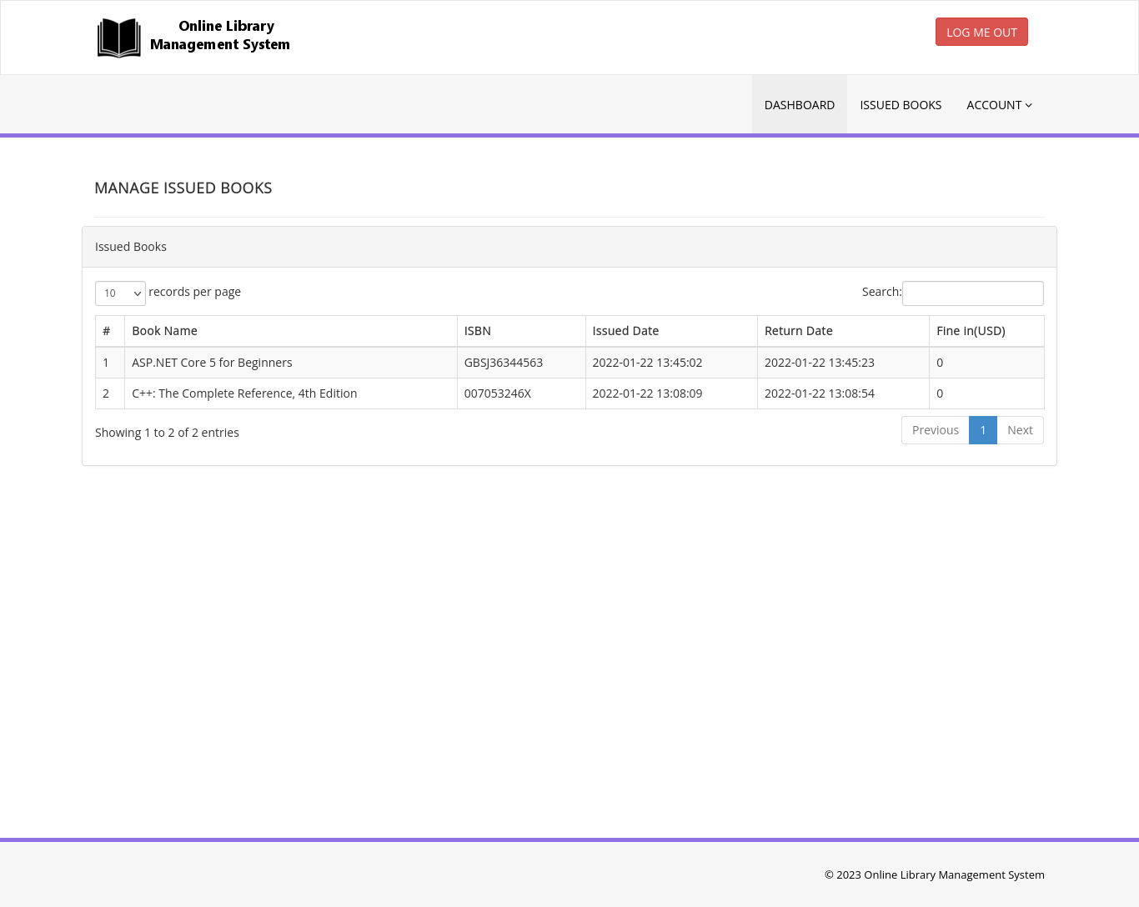

**Admin Login:**

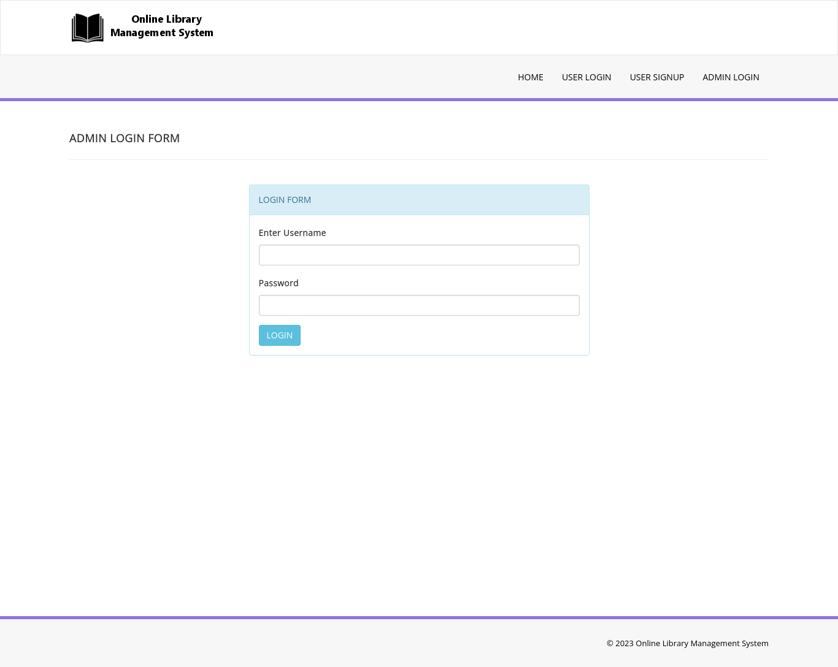

**Chapter 6**

**System Testing**

The aim of the system testing process was to determine all defects in our project .The program was subjected to a set of test inputs and various observations were made and based on these observations it will be decided whether the program behaves as expected or not. Our Project went through two levels of testing:

1. Unit testing
2. Integration testing

**Unit Testing:**

Unit testing is undertaken when a module has been created and succesfully reviewed .In order to test a single module we need to provide a complete environment ie besides the module we would require:

* The procedures belonging to other modules that the module under test calls
* Non local data structures that module accesses
* A procedure to call the functions of the module under test with appropriate parameters

1. **Test For The Admin Module:**

* **Testing admin login form:**

This form is used for log in of administrator of the system.In this we enter the username and password if both are correct administration page will open other wise if any of data is wrong it will get redirected back to the login page and again ask for username and password

* **Student account addition:**

In this section the admin can verify student details from student academinc info and then only add student details to main library database it contains add and delete buttons if user click add button data will be added to student database and if he clicks delete button the student data will be deleted.

* **Book Addition:**

Admin can enter details of book and can add the details to the main book table also he can view the books requests .

1. **Test for Student login module:**

* **Test for Student login Form:**

This form is used for log in of Student .In this we enter thelibraryid, username and password if all these are correct student login page will open other wise if any of data is wrong it will get redirected back to the login page and again ask for libraryid, username and password.

* **Test for account creation:**

This form is used for new account creation when student does not fill the form completely it asks again to fill the whole form when he fill the form fully it gets redirected to page which show waiting for conformation message as his data will be only added by administrator after verification.

1. **Test for teacher login module:**

* **Test for teacher login form:**

This form is used for logg in of teacher .In this we enter the username and password if all these are correct teacher login page will open other wise if any of data is wrong it will get redirected back to the login page and again ask for username and password.

**6.2 Integration Testing**

In this type of testing we test various integration of the project module by providing the input. The primary objective is to test the module interfaces in order to ensure that no errors are occurring when one module invokes the other module.

**Chapter 7**

**Conclusion & Future Scope**

This website provides a computerized version of library management system which will benefit the students as well as the staff of the library.

It makes entire process online where student can search books, staff can generate reports and do book transactions. It also has a facility for student login where student can login and can see status of books issued as well request for book or give some suggestions. It has a facility of teacher’s login where teachers can add lectures notes and also give necessary suggestion to library and also add info about workshops or events happening in our college or nearby college in the online notice board.

There is a future scope of this facility that many more features such as online lectures video tutorials can be added by teachers as well as online assignments submission facility , a feature Of group chat where students can discuss various issues of engineering can be added to this project thus making it more interactive more user friendly and project which fulfills each users need in the best way possible

**Chapter 8**

**References**

* http://www.w3schools.com/html/html_intro.asp
* https://www.w3schools.com/php/default.asp
* https://www.w3schools.com/sql/default.asp
* Fundamentals of software engineering by Rajib mall, PHIlearning
* Web development and application development by Ivan Byross BPB publications